### Probability and Statistics - IT2120

Lab sheet : 10

Name : Manthrirathna S.N

ID : IT24102791

1.Null Hypothesis

Customers choose all snack types (A,B,C, D)with equal probability.

pA​=pB​=pC​=pD​=0.25

Alternative Hypothesis

Customers **do not** choose all snack types with equal probability.

2.

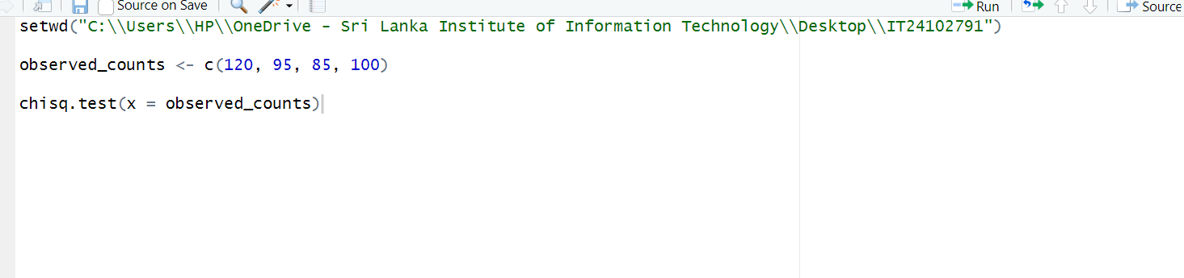

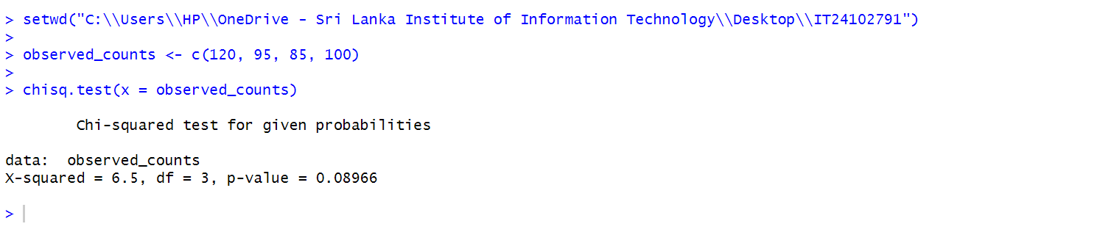

3. the p-value is not less than 0.05, we do not reject the null hypothesis. There is **not enough statistical evidence** to reject the vending machine owner's claim that customers choose the four snack types with equal probability.